1. Setup Postman API and Make different types of HTPP call using

Postman, GET, PUT, POST, and DELETE.

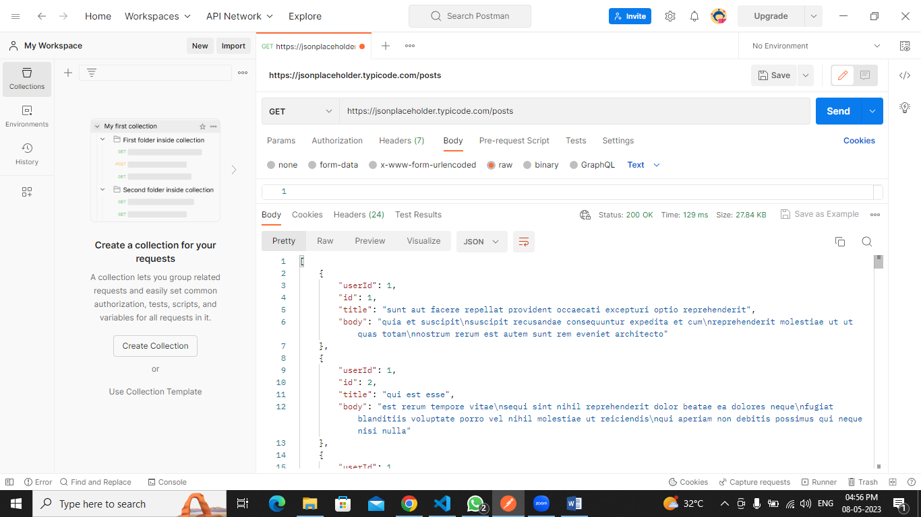

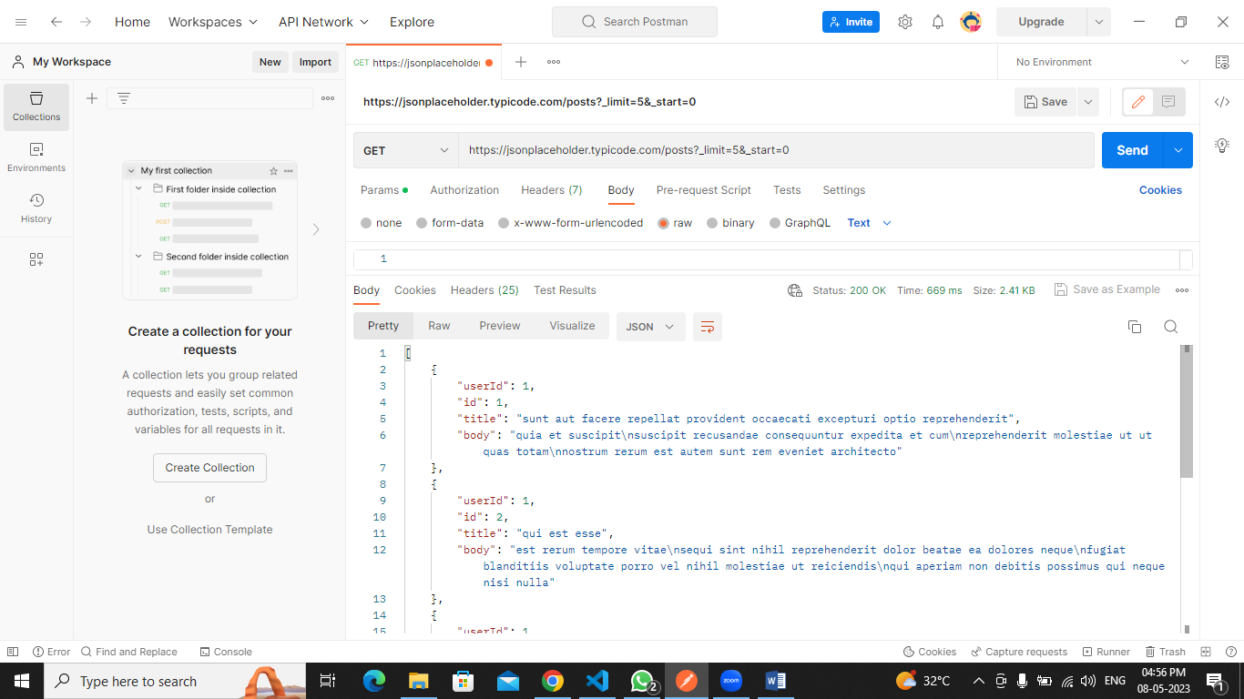

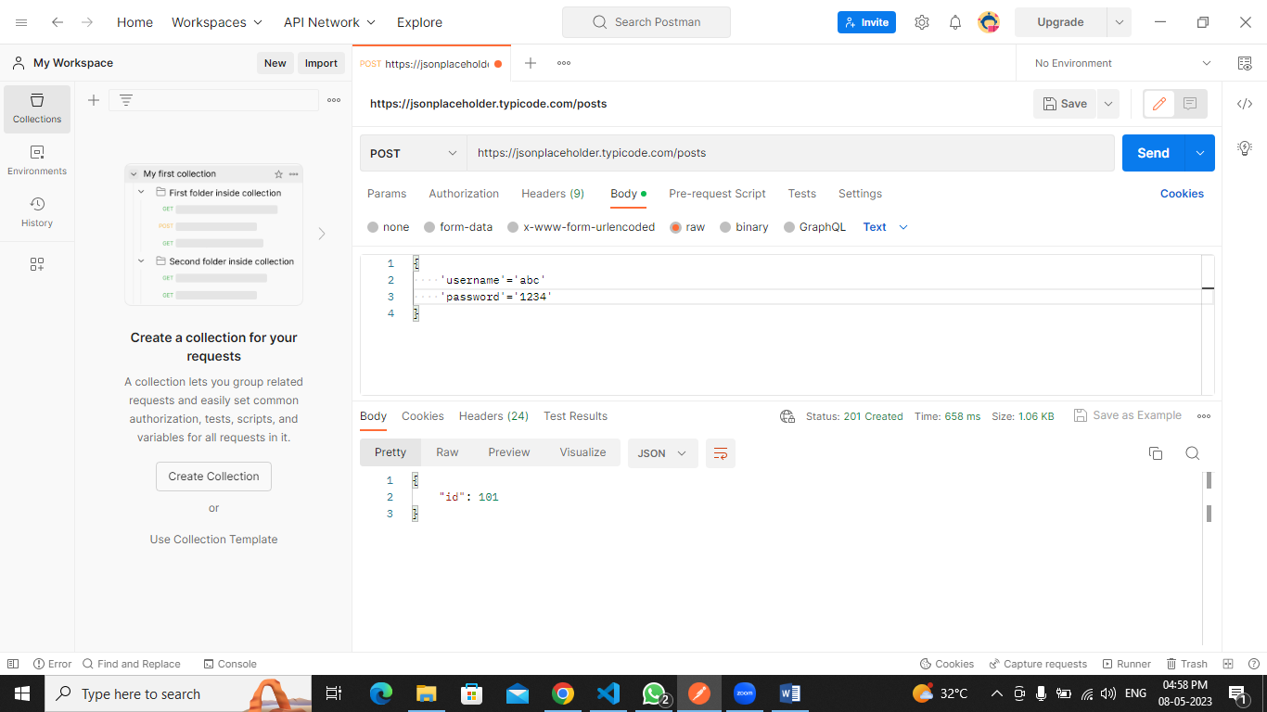

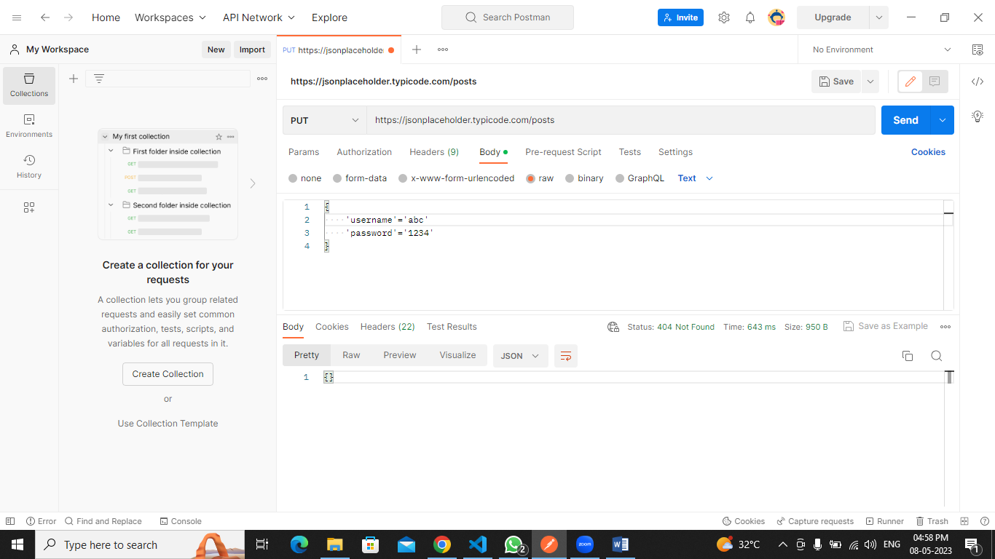

2. Setup VS Code Write a program to print your name using VS Code.

<!DOCTYPE html>

<html>

<head>

<meta charset='utf-8'>

<meta http-equiv='X-UA-Compatible' content='IE=edge'>

<title>My first HTML</title>

<meta name='viewport' content='width=device-width, initial-scale=1'>

<link rel='stylesheet' type='text/css' media='screen' href='main.css'>

<script src='main.js'></script>

</head>

<body>

Hello.. My name is Paresh from TVM

</body>

</html>

